Regions By Heritage Ended

Top Danger Sites prone to Extinction

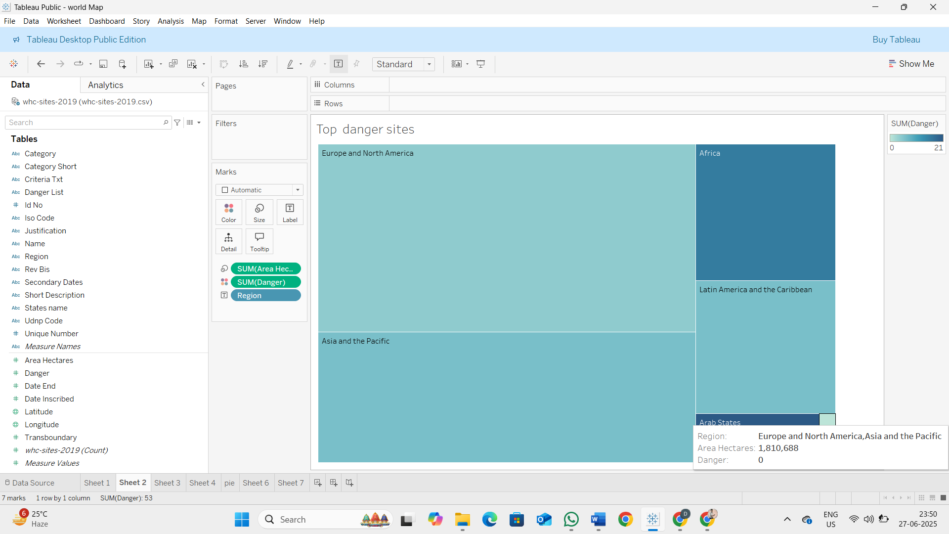

Countries per Region

Year Forecasting of Heritages

 Site Count per Region

Categories by sites count

Analysis of Danger sites and Area of heritages

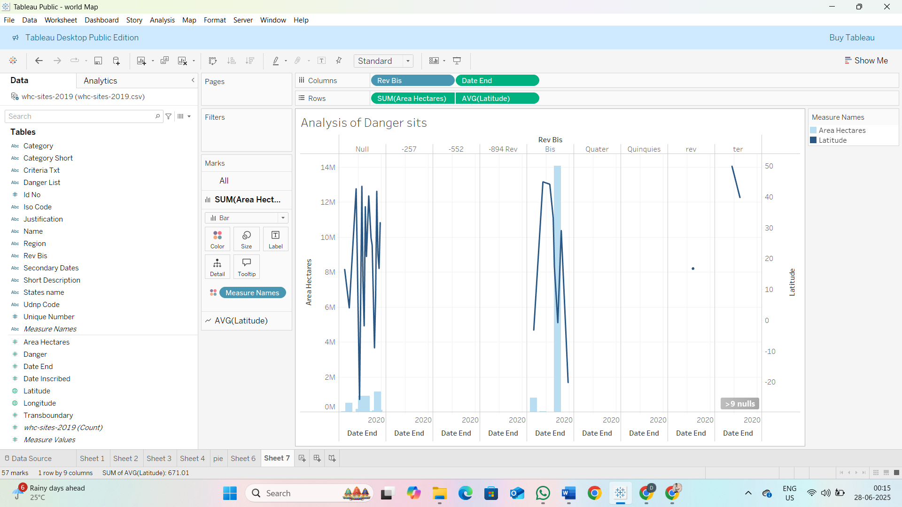

Regions By Area

